Torsion of Open and Closed Thin Wall Members

ASEN 3112

Group 1-F

Mark Middleton
Will Dalbec
Joshua Johnson
Michael Miller
Eric Schleicher
Robert Thornton

Fall 2000

1.0 Introduction

The goal of experimental lab 1 was to compare the measured shear strain and the ratio of the twist angle to the shear strain when exposed to a torque. To accomplish this, two different specimens were used in the testing. The first specimen was a closed thin wall square tube capable of withstanding 500 lbs-in maximum torque. The second specimen was an open thin wall T channel profile capable of withstanding 10 lbs-in maximum torque. Both specimens were constructed out of aluminum T6 alloy. Completing this lab will provide insight into internal forces created from torque being applied to a material. A complete understanding of torsion testing, and methods for mathematically modeling a specimen under these types of loads were developed. Explanation for the open thin wall specimen having a significantly lower maximum torque rating compared to the closed thin wall specimen will be discussed. Also, sources of error causing the mathematical model to differ from the measured values will also be considered.

2.0 Experimental Procedure

The laboratory procedure began with setting up the Tinius Olsen torsional testing device and connecting the cables to the computer. The next step was to open the LabView VI and run the torsional stress program. A test specimen was loaded and clamped into the machine, and the strain reading in LabView VI was set to zero. It was very important to zero the program to get an accurate reading during the experiment. This task was accomplished by adjusting the screws on the military plug that connected the Tinius Olsen to the computer station, and watching to see when the computer strain display read zero. Once preparation was complete, the experiment began by placing the safety guard over the apparatus and starting the machine. The torsion was created by setting a rate at which the clamps would rotate. LabView recorded the strain from three different strain gauges on the test piece, as well as strain information provided by the Tinius Olsen. Torsion was terminated before the test piece fractured, and the rotation was reversed until the torsion was released.
Two specimens were tested in this laboratory experiment with the above procedure. The first was an open thin wall section with a T channel profile, as depicted in Figure 1a. This specimen had a thickness of 0.066 in., flange width of 1.0 in., web width of 0.75 in., and clamp-to-clamp length of 13.0425 in. The second test item, illustrated in Figure 1b, was a closed thin wall section with a square tube shape. This piece measured 0.05 in. thick, 1.0 in. high, 1.0 in. wide, and 12.825 in. from clamp to clamp.

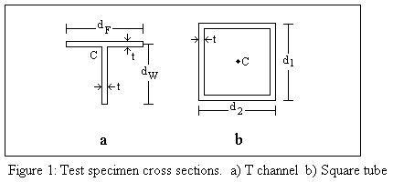

Both pieces were outfitted with three strain gauges placed in the lengthwise center, one at 45⁰, one at 90⁰, and one at 135⁰ from the side of the specimen. The T channel section had the gauges in the center of the web, and the gauges of the square tube were on the center of one of the faces.

3.0 Theoretical Analysis

The first of the two theoretical values needed for comparison is the value of the shear strain (γ). The first step in determining the values is to select coordinate axes. The axes to be chosen are set so that the x-axis runs along the longitudinal direction of the specimen and the z-axis is perpendicular to its surface.
With the coordinate axes set, the next step is to determine the stresses (τ) on the specimen. The value of τ can be determined by appropriate thin wall (TW) section torsion formula. Each of the two specimens requires a different formula, because one was an open TW and one is a closed.
The T channel profile was the open TW section. An open TW section can be modeled using a narrow rectangle. This means that the only important shear stress is τ_{xy} and therefore τ_{xy} = τ. This means that the maximum shear on the on the rectangle can be defined as:

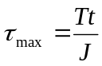 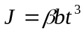 (1)

where T is the torque, t is the thickness of the of the rectangle, b is the length of the long side and β is a parameter of the piece. Because the b >> t, the value of β can be considered to be 1/3 (Felippa 2).
In order to solve for the value of the τ of the T section, two assumptions must be made. The first is to divide the specimen into two rectangular parts, which was done in the lab handout (See Figure 2). The second is to realize that the total torque on the system is the sum of the torque on each of the two parts, and therefore the sum of the individual J is equal to the total J of the system (Felippa 3). Therefore, the τ can be determined to be:

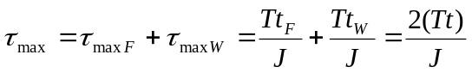 (2)

where 2(Tt) can be used because the thickness’ of both sections are equal (Felippa 3)

The square tube profile was the closed TW section. A closed section is any section that is assumed to have an uninterrupted shear flow (q), or internal force per unit length that is tangential to the wall. Shear flow can be defined by the equation:

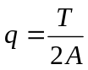 (3)

where A is the area contained inside the wall’s midline. Therefore, the shear stress can be defined as:

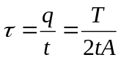 (4)

where t is the thickness of the wall and A is the area inside the square tubes midline (Fellipa 5).
With the τ value found, the third step is to calculate the value of γ. Since τ_{xy} = τ, the value of γ is the same as γ_{xy}. Therefore γ is calculated using the equation:

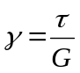 (5)

In order to compare this calculated value with the data from the strain, the proper 2D strain transformation was used to calculate the normal strains on each gage in the rosette. For a rectangular rosette, the type which is used hear, the transformation is:

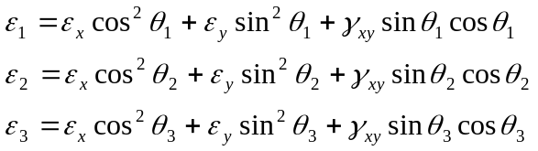 (6)

using the angles of ε₁ = 135°, ε₂ = 45°and ε₃ = 90° ( Popov 509). After the calculation of the values, the equations for ε₁ and ε₂ are added to get the value of γ in terms of ε₁ and ε₂, the new equations produced are:

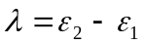 (7)

The second of the two theoretical values to be compared is the angle of twist (φ) over the distance between the grips (L). In order to do this comparison, the ratio of φ/γ is used so that the value of G does not influence the calculation. As before, there are different methods of finding the value of φ open and closed TW sections. However, unlike before, the two methods come from the same base equation:

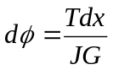 (8)

where T is the torque applied and G is the shear modulus (Felippa 2). This equation can be simplified to make it function of L, making it:

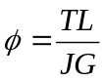 (9)

When divided by γ for the comparison, the equation produced is:

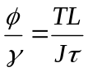 (10)

from equations 5 and 9, where it can be seen that G is canceled out of the equation. The differences in the two TW calculations come from the calculation of J. For the open TW section, J is calculated using equation 2. The closed TW section J is calculated using the equation:

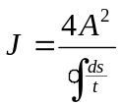 (11)

where A is the area to the walls midline and 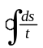is the thickness as a function of its position along the perimeter (Fellipa 5). Since the thickness is constant, it will reduce to p/t, t is the thickness and p is the perimeter of the area A.

4.0 Data Reduction and Presentation

Table 1: Selected data for T-cross section member.

Torque (in. lb.) | Measured Shear Strain | Calculated Shear Strain | Calculated phi/gamma | Measured phi/gamma
1.25 | 324.20 | 131.63 | 194.89 | 79.13
1.34 | 346.60 | 141.19 | 194.89 | 79.39
3.76 | 633.00 | 394.89 | 194.89 | 121.58
10.16 | 1432.20 | 1067.31 | 194.89 | 145.23
10.05 | 1436.40 | 1055.76 | 194.89 | 143.24

Table 2: Selected data for square-cross section member.

Torque (in. lb.) | Measured Shear Strain | Calculated Shear Strain | Calculated phi/gamma | Measured phi/gamma
133.40 | -233.20 | 394.16 | 27.08 | -45.77
134.80 | -234.60 | 398.30 | 27.08 | -45.97
222.20 | -24.64 | 656.55 | 27.08 | -721.53
480.90 | 613.40 | 1420.94 | 27.08 | 62.73
480.60 | 610.60 | 1420.06 | 27.08 | 62.98

5.0 Discussion

5.1 Open Thin Wall Member: T section

In the comparison of the experimental and calculated values of shear strain, it can be seen that the shear strain has close to the same rate of change with respect to torque. The theoretical strain has a rate of change with respect to torque of .0095 in-lb, and the rate of change of the measured strain with respect to torque is .008 in-lb. See Figure 2.

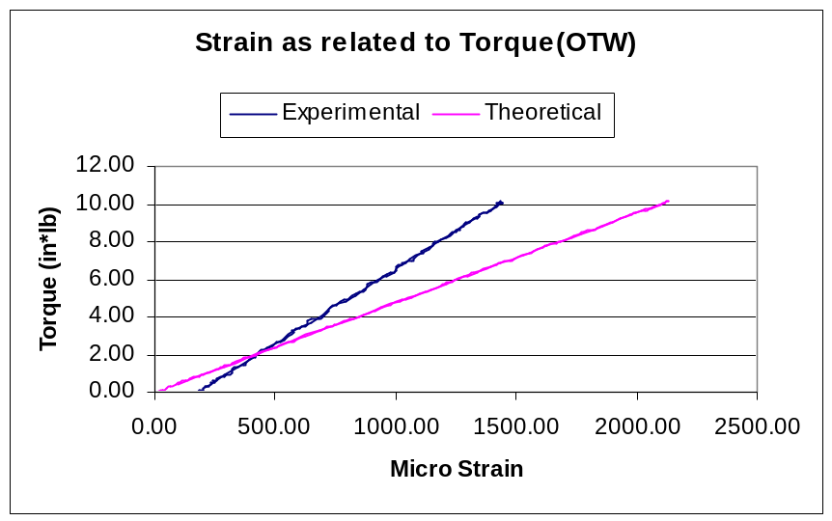
Figure 2

The error between the slopes is 15%. This is .8% lower than the error between the slopes on the square cross section, as will be discussed in the next section. The theoretical strain values for the open section are calculated using Equations (1) and (5). These equations show that the shear strain depends on the elastic modulus of the material, the torque applied to the beam, and the physical dimensions of the cross section. The same torque applied was used for both experimental and theoretical results. The physical dimensions are important because they are what determine the cross-sectional moment of inertia, J. Therefore, either the material properties not being exact or the dimensions of the beam not being exact can explain the error in the rate of change of shear strain with respect to torque. Since careful measurements were made of the dimensions, the error must lie in incorrect material properties, namely the shear modulus. The actual specimen may have had different properties due to being repeatedly subjected to torques. The shear strains obtained by experiment for the open thin wall member were lower than the relative calculated values by an average amount of –293.5. The difference between the measured and calculated strains is smallest at low torque values and increases with increasing torque.
It was confirmed that the relationship between torque and twist angle is linear by the experimental data. In the experiment, the twist angle changed slower with respect to torque than theory would predict. However, it reached a greater twist angle than was predicted by the theoretical results for the same torque. This could be because of the chucks slipping on the beam or from the construction of the beam being different from the modeled construction (i.e. welds or angles that are not exact). The results for this can be seen in Figure 3.

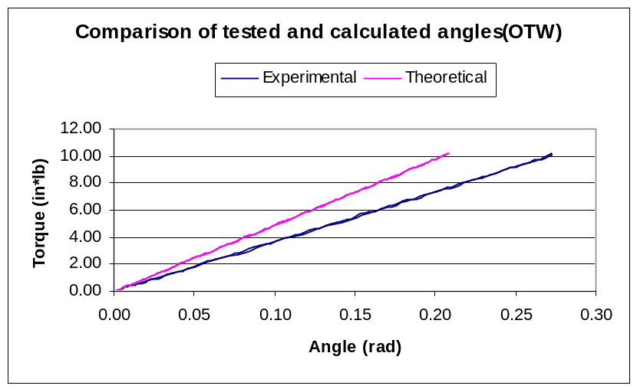
Figure 3

The ratio of the twist angle to the shear stress, as calculated by equation (10), produced a constant with respect to angle in theory. This however did not coincide with the measured values. The measured values have a slope which is indirectly proportional to the angle. This means that at small angles the slope is high and as you move out to higher angles the slope flattens out until it reaches zero. The measured values could be different due to several reasons. The most likely of these is that the chuck could have slipped on the beam which would cause the angle read by the machine to be larger than the angle that the beam was actually rotated. Other reasons could involve defects in the material, defects in the construction of the beam, or a problem with the model used to predict the reactions of the beam. The results of this section of the lab are shown in figure 4 on the next page.

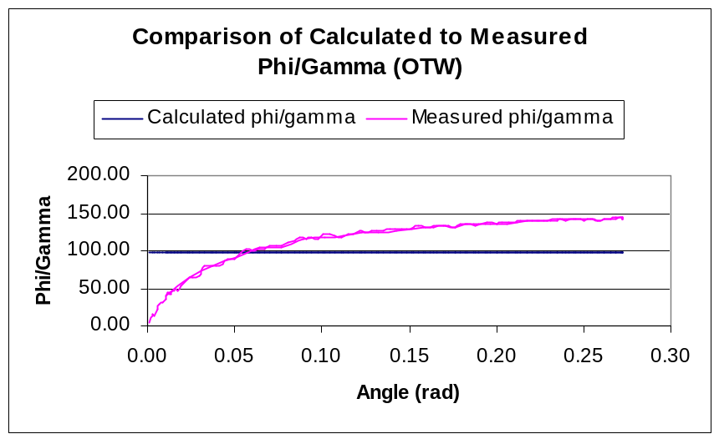
Figure 4

5.2 Closed Thin Wall Member: Square section

The first part of the lab involved testing a closed thin walled beam that was fabricated in the shape of a square. The values that will be compared first are the strains of the closed beam. When the values for the calculated and the measured strains are compared the measured strain is twice as large as the calculated strain. When the measured and calculated strains are compared on a plot versus torque their slopes came out to be the same. This is shown in figure 5 below.

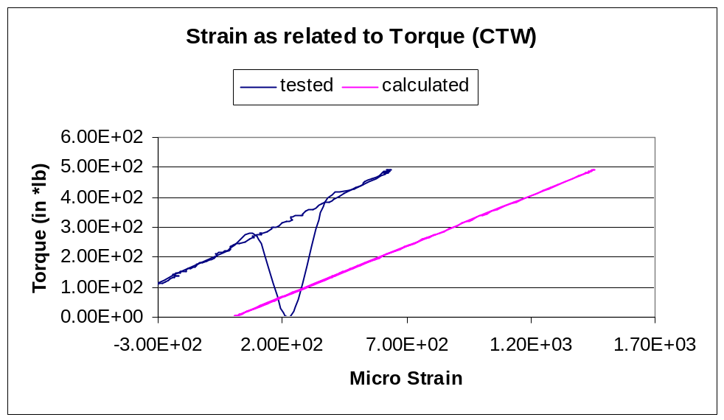
Figure 5

This shows that the theory for calculating the strain is correct. However either the initial values on the measurement machine were off or the theory has some initial condition that would account for the graph being shifted over. The slope for the tested data is .4023 while the slope for the calculated data is .3384 this gives an error between the two of 15.8 %. The second quantity then was compared was the twist angle of the beam. For this there was again a calculated quantity and a measure quantity. Figure 6 (below) shows these twist angles plotted versus the torque that was applied to the beam.

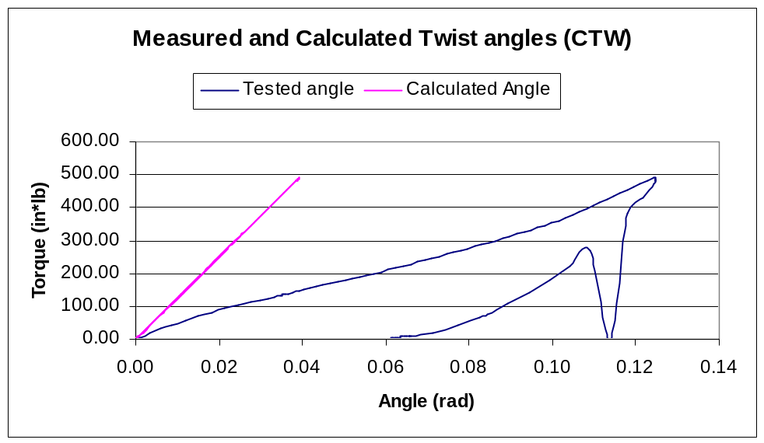
Figure 6

As the graph shows the two slopes for the change in twist angle as related to torque are not the same. In this graph the lines start at the same spot. The possibility of a zeroing problem can be ruled out because the lines start at the same spot. The reason for the slopes being different could be because the clamps slipped on the beam while the torque was applied or a flaw in the model of the beam. The flaw with the model could be because of flaws added to the beam when it was welded together. The difference in slopes could also be due to changes in the properties of the metal due to it being tested repeatedly. The last value that was compared for the closed beam was the ratio of the twist angle in the beam divided by the shear strain of the beam. This was done using stresses found by using the model and calculating them, and through direct measurements done by the machine. Figure 7 is a graph of these ratios versus the angle measured by the machine.

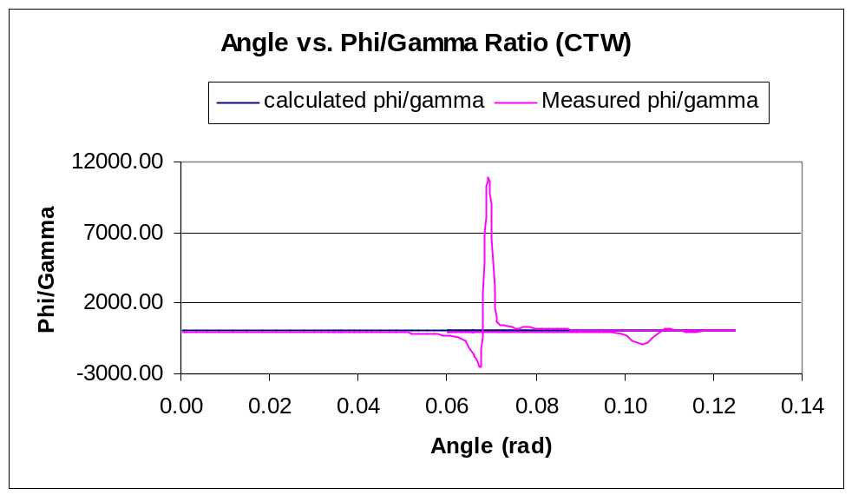
Figure 7

As the figure above shows the measured ratio of phi to gamma was nearly exactly the same as the calculated value. The only deviation from the model occurs when the machine was turned off and reversed this is where the spike in the graph occurs. The other smaller deviations that occur near .1 could be from the chuck slipping on the beam or from errors in the data read from the testing machine.

6.0 Conclusion

In analyzing the open thin walled specimen the equations for shear stress and twist angle were confirmed to be linear relationships. The error in the strain to torque comparison could be attributed to incorrect material properties or material weakening. Also errors in the strain gage plus calibration error would have affected the measured strain. Despite the inherent errors the linearity of the theoretical and measured strain as a function of torque was shown. The measured twist angle as a function of torque increased slower then theoretical calculations suggested. However, the maximum twist angle measured was higher then the theoretical model. This discrepancy is possible related to exposing the specimen to repeated torques weakening the specimen over time. The phi/gamma as a function of angle yielded a constant value, but the measured phi/gamma ratio showed a slope inversely related to the twist angle. The measured slope approached zero as the twist angle was increased demonstrating a trend that more closely agreed with the theoretical results. The high degree of error encountered for lower twist angles could be related to flaws in the material, slipping and/or errors inherent with the data collection. The discrepancy between the maximum measured phi/gamma ratio and the calculated phi/gamma ratio is possible due to initial condition errors.
The same trends and relationships were observed for the closed thin walled specimen. The measured strain as a function of torque slope was shifted to the left of the calculated values. This is most likely due to the initial condition of the strain gage. Unfortunately, the comparison between measured and theoretical twist angle as a function of torque showed significant deviation. Slipping, flaws in the material, repeated testing and inaccurate data collected for the torsion-testing machine are all possibilities accounting for the error. The final plot for the closed thin wall specimen, showing the phi/gamma ratio as a function of twist angle, demonstrated very close agreement. In both the measured and calculated phi/gamma ratios a constant value was obtained. The spike in the plot for the measured phi/gamma ratio was caused when the machine was stopped and torque was returned to zero. In both cases nearly the same values were achieved demonstrating the validity of the mathematical model. The mathematical models for both the open and closed thin wall specimens were verified. Also, addition insight into torsion testing and methods to predict specimen behavior under these types of loading conditions was obtained.

References

- Popov, Egor P. Engineering Mechanics of Solids (second edition) Prentice-Hall 1998
- Felippa, C. ASEN 3112 Lab 1 Description. Handout, ASEN 3112. Fall 2000.
- Felippa, C. Operational Manual for Lab 1. Supplement to ASEN 3112 Lab 1 Handout, ASEN 3112. Fall 2000.

